Hearts on Fire
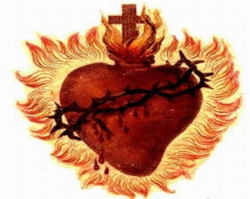
SPREAD SUMMER RETREAT
AUGUST 3-4, 2024
St. Joseph Retreat Center, Tipton, Indiana
“Therefore, encourage one another and build one another up, as indeed you do.”
1 Thessalonians 5:11
Retreat Forms will be available by June 1, 2024
For Adults with Developmental and Intellectual Disabilities

